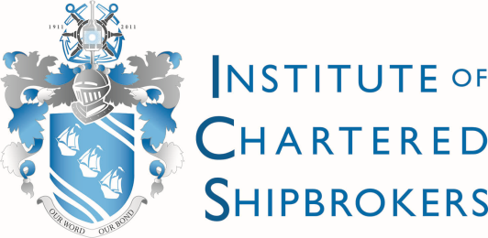
Institute of Chartered Shipbrokers
Denmark Branch
The Future of Shipping  17:30hrs, 3rd December 2015 | The Institute of Chartered Shipbrokers  Denmark Branch  invites you to an evening with  Peter Sand, BIMCO,  speaking on The Future of Shipping. |  | 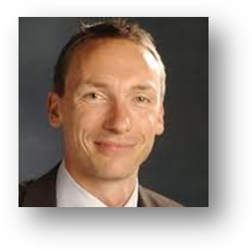
Venue
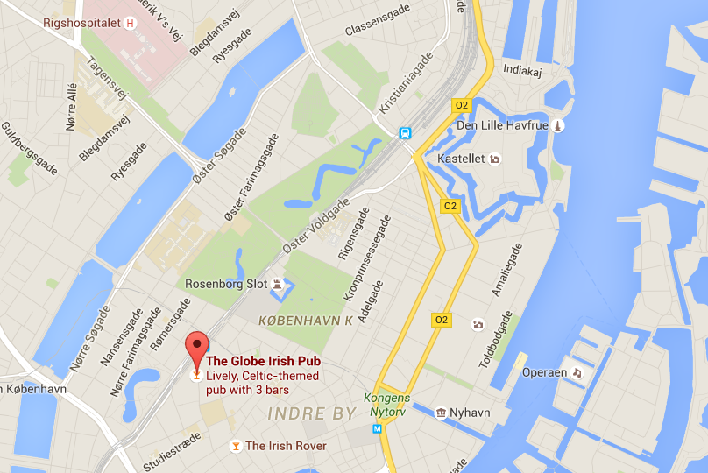 |  |  | The event will take place on  the 3rd December 2015 at 17.30hrs  at the Pub  ‘The Globe’  Nørregade, 43  in København.  The allocated room is for a  maximum of 50 people.  Free drinks and appetizers  will be served.
Bookings | Booking can be done via email at: denmarkbranch@ics.org.uk | Please reply with your name, contact details and company.
 | Bookings will be confirmed on a first come first served basis.
Looking forward to seeing many of you there!

Institute of Chartered Shipbrokers
Denmark Branch

